
YEAR 11
General Human Biology: Task Five

Student name _________________________ Teacher ____________________________

TEST: CIRCULATORY SYSTEM Weighting: 4%
Working time for paper: 45 Minutes
Materials to be provided by the student:
Blue/Black Pen, pencil, eraser or correction fluid, and ruler
Marks available:
 | Number of questions available | Suggested working time (minutes) | Marks available | Student score
Part A: Multiple-choice | 5 | 6 | 5
Part B: Short answer | 5 | 29 | 17
Part C: Extended answer | 1 | 10 | 6
Totals | 11 | 45 | 28
Teacher Feedback:

Part A: Multiple Choice

- What is the difference between arteries and veins?
- Arteries carry oxygenated blood and veins carry deoxygenated blood
- Arteries carry deoxygenated blood and veins carry oxygenated blood
- Arteries carry blood away from the heart and veins carry blood back to the heart

- What blood component is important to blood clotting?
- Plasma
- Red Blood Cells
- Platelets

- What is the function of valves in the heart?
- To prevent blood flow through the lungs
- To control blood flow through the heart
- To separate the chambers of the heart

- How many chambers are there in the heart?
- 4
- 3
- 5

- Why is blood red?
- When combined with oxygen, haemoglobin is red
- When combined with carbon dioxide, haemoglobin is red
- Haemoglobin is red regardless of what it is combined with
Part B: Short Answer

- Describe three of the functions of blood. (3 marks)
___________________________________________________________________________________________________________________________________________________________________________________________________________________________________________________________________________________________________________________________________________________________________________________________________________

- What are the components of blood? (2 marks)
____________________________________________________________________________________________________________________________________________________________________________________________________________________________________________________________________________________________________________________________

- Why does blood return to the heart? (2 marks)
___________________________________________________________________________________________________________________________________________________________________________________________________________________________________________________________________________________________________________________________________________________________________________________________________________
- Why are the walls of veins thinner than in arteries? (2 marks)
___________________________________________________________________________________________________________________________________________________________________________________________________________________________________________________________________________________________________________________________________________________________________________________________________________

- Label the diagram below. (8 marks)

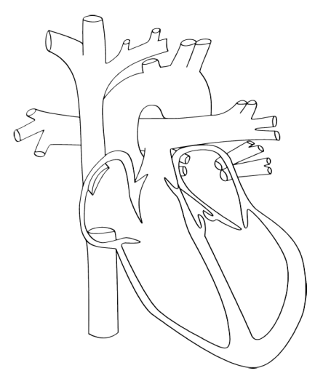

Part C: Extended Answer

- Identify and describe one disease of that affects the circulatory system. Include reference to symptoms and treatments (6 marks)
_______________________________________________________________________________________________________________________________________________________________________________________________________________________________________________________________________________________________________________________________________________________________________________________________________________________________________________________________________________________________________________________________________________________________________________________________________________________________________________________________________________________________________________________________________________________________________________________________________________________________________________________________________________________________________________________________________________________________________________________________________________________________________________________________________________________________________________________________________________________________________________________________________________________________________________________________________________________________________________________________________________________________________________________________________________________________________________________________________________________________________________________________________________________________________________________________________________________________________

